Roboanalyzer Mini Project

Note: In the Roboanalyzer application, I multiplied all link lengths by 0.1 to make them smaller and make it easier to view the 3D model since it was large with meters.

**Simulated Trajectory:**

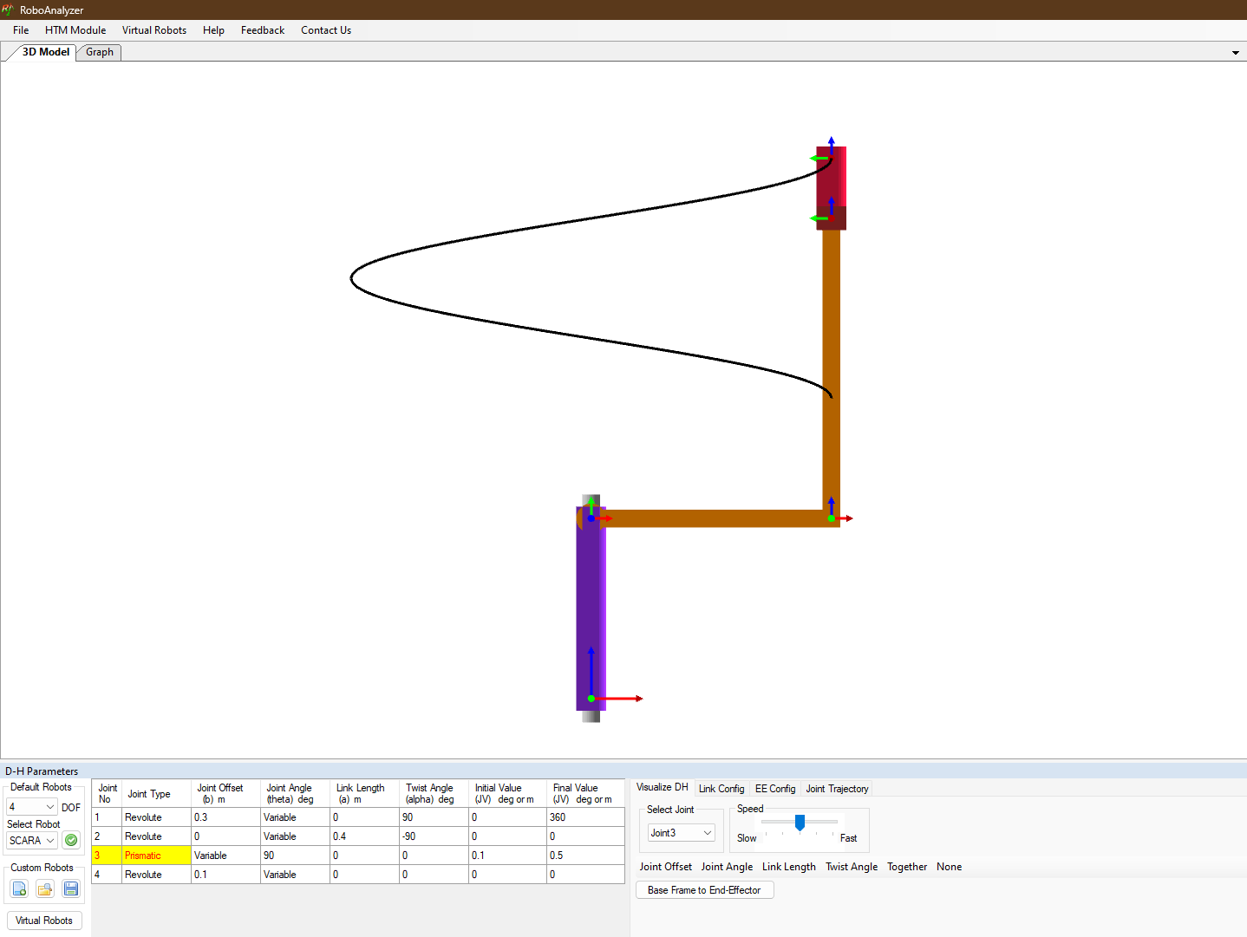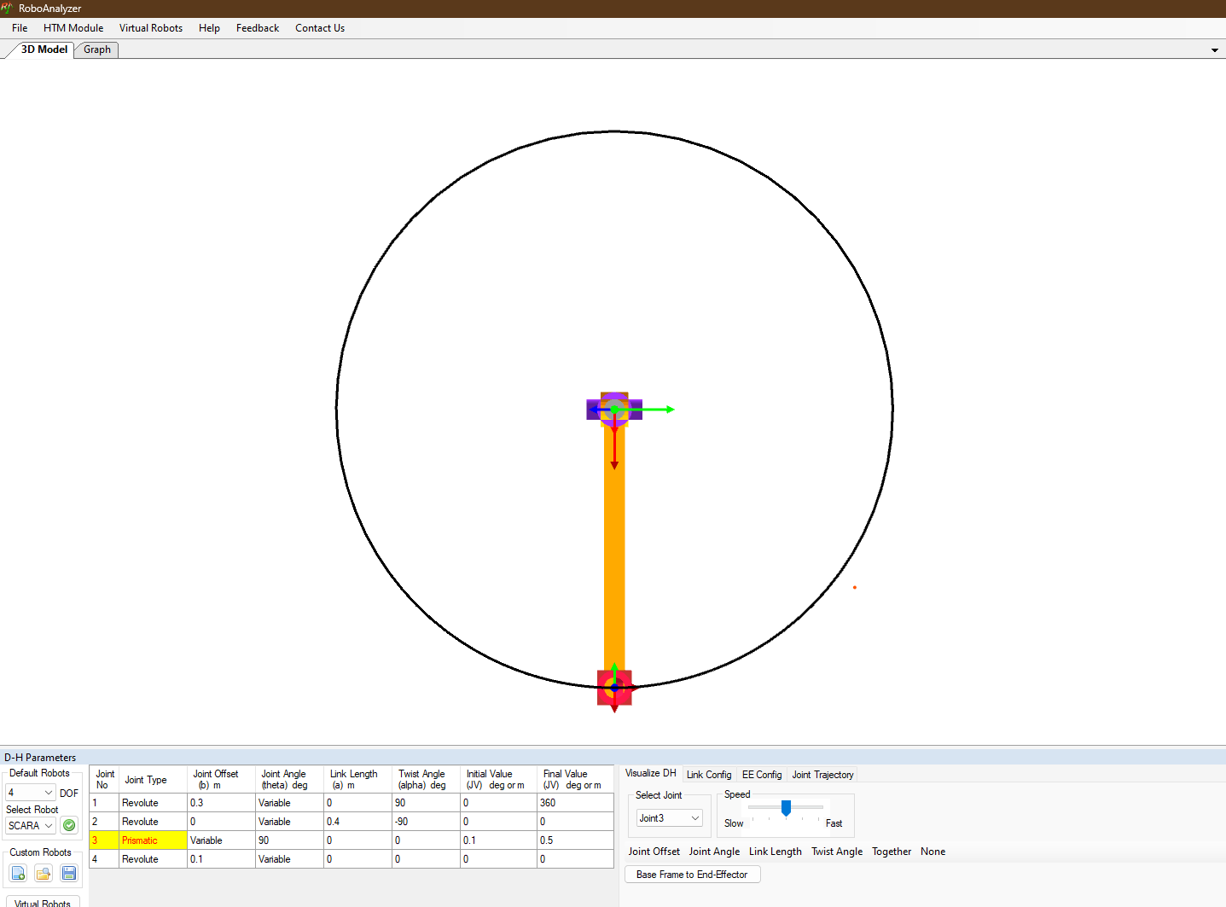

**Plots for Joint Space Trajectories:** 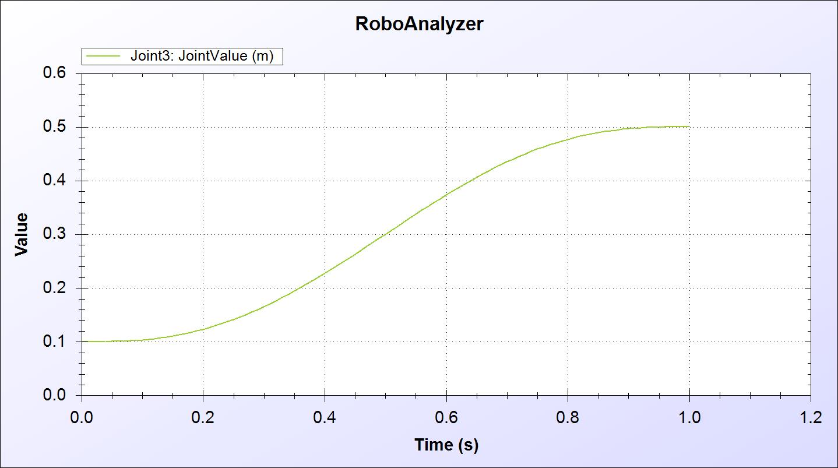

*Graph #1: Prismatic Joint Length Over Time*

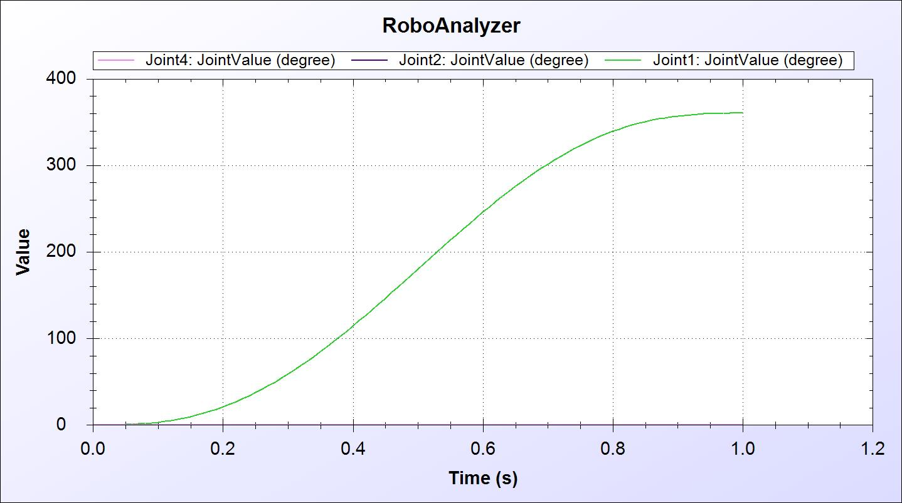

*Graph #2: Joint Angles Over Time (only joint 3 was moved, the rest are at zero)*

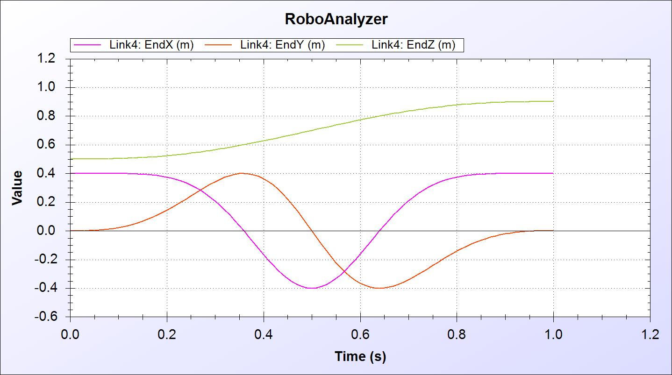

*Graph #3: End-Effector Position Over Time*

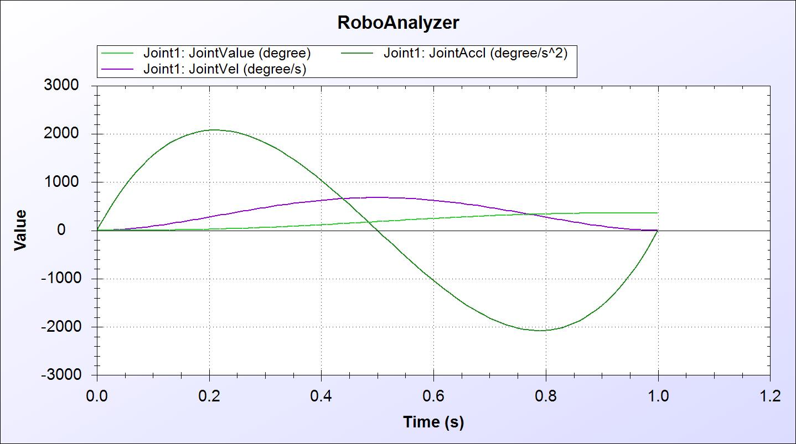

*Graph #4: Joint 1 Position, Velocity, and Acceleration Over Time (Joint rotated 360 degrees)*

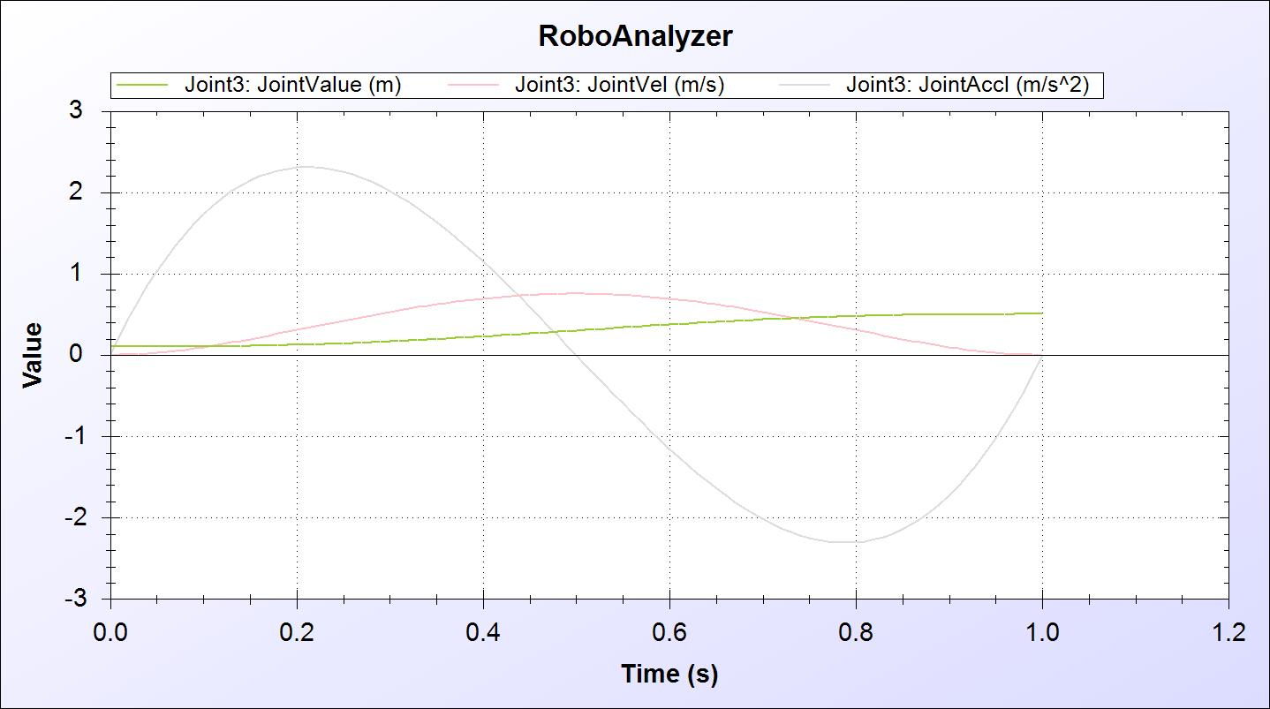

*Graph #5: Joint 3 Position, Velocity, and Acceleration Over Time (Prismatic Joint)*